# To find the code that contains the requests (useful if no Swagger documentation available)

In Solution Explorer, go to the project where the API code resides (in this example Portal.Backend.Api)

Select the Controllers folder and then the file for the are you are testing:

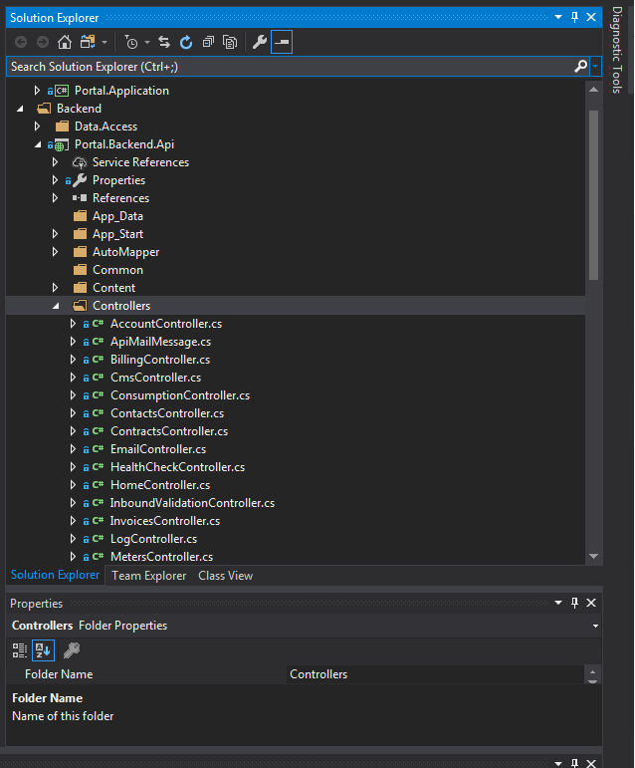

Open that file to display the code.

The RoutePrefix will the part of the URL that comes after the server name (e.g. <http://porapp01qa:81>)

This will be followed by the Route for each service

In this example, the URL for the Save service would be :

<http://porapp01qa:81/api/tpi/registration/save>

